Sat query Idea doc

Ps:
SatQuery AI is an agentic remote-sensing VLM system that allows users to analyze satellite images using natural-language queries.
It must support single-image VQA + one additional task (captioning/grounding) and bi-temporal change analysis.
It must also perform joint optical–SAR analysis to extract complementary information from both modalities/datatype.
The system requires remote-sensing adaptation/fine-tuning and an agentic controller that selects and orchestrates appropriate specialist models.
The final deliverable is an interactive GUI/web application with the AI backend, visual evidence, confidence, execution trace, and downloadable reports.

Full PS:
Background Remote-sensing imagery is widely used for agricultural monitoring, disaster management, urban planning, forest monitoring, water-resource assessment, infrastructure mapping, and environmental analysis. However, most existing remote-sensing AI solutions are developed as isolated applications for a single predefined task, such as land-cover classification, object detection, visual question answering, or change detection. These systems often require users to understand satellite-data characteristics, GIS workflows, model selection, and task-specific parameters. Consequently, non-expert users may find it difficult to obtain meaningful information from satellite imagery through simple natural-language queries.
Many operational remote-sensing questions cannot always be answered reliably using a single optical image. Relevant information may be distributed across paired or multiple observations acquired at different times or by different sensors. Optical and multispectral imagery provides spectral and contextual information, whereas synthetic aperture radar (SAR) provides complementary structural information and supports day-and-night acquisition through cloud cover. Multitemporal image pairs are required to identify and interpret changes over time, while co-registered opticalâ€“SAR pairs can provide more complete and reliable information than either modality alone.
A general-purpose large language model (LLM) or vision-language model (VLM) cannot be expected to perform these specialised tasks reliably without adaptation to remote-sensing imagery, sensor characteristics, and domain-specific terminology. The proposed solution must therefore include remote-sensing fine-tuning or domain adaptation and may employ multiple specialised models for different tasks. BigEarthNet.txt will serve as the primary dataset for adapting imageâ€“text representations to multisensor remote-sensing data. VRSBench and RSVQA will be used to evaluate single-image captioning, grounding, and visual question answering, while CDVQA will be used to evaluate multitemporal change-based visual question answering.
The novelty of SatQuery AI lies in its agentic, query-driven framework. Instead of applying a single generic VLM, the system selects and executes suitable remote-sensing specialist models, validates inputs, combines their outputs, and returns an evidence-grounded response.
Description The objective is to develop SatQuery AI, a software-based agentic vision-language assistant for analysing single and paired remote-sensing images through natural-language queries. Single-image understanding is a mandatory baseline, while the principal focus is joint reasoning over paired cross-modal and multitemporal imagery.
Defined Input Scope
• Single image: One optical/multispectral or SAR image for captioning, visual question answering, and text-guided region grounding.
• Cross-modal pair: Co-registered optical/multispectral and SAR images of the same geographic area for joint information extraction and cross-modal analysis.
• Bi-temporal pair: Two spatially corresponding images of the same geographic area acquired at different times for change detection, change description, and change-based visual question answering.
• Supported formats: GeoTIFF or TIFF for geospatial imagery. PNG and JPEG inputs may be accepted only for the prescribed public benchmark datasets.
Mandatory Functional Scope
• Remote-sensing adaptation: At least one visual or vision-language component must be fine-tuned or otherwise adapted using BigEarthNet.txt or the any open source training data.
• Single-image baseline: Visual question answering shall be mandatory. Each solution must additionally implement either captioning/scene description or text-guided region grounding.
• Multi-image change analysis: Change description or change-based visual question answering from a bi-temporal image pair shall be mandatory. A spatial change map may also be generated where reference masks are available.
• Cross-modal pair analysis: The system must extract complementary information from a co-registered optical/multispectral and SAR image pair.
• Agentic orchestration: The system must automatically select, sequence, and execute the appropriate specialist models or tools according to the query and input configuration.
Representative Queries
• 'Describe the land-cover and major objects visible in this image.'
• 'Highlight the water body referred to in the query.'
• 'What changed between these two dates, and where did the change occur?'
• 'Use the optical and SAR images together to identify built-up and water-covered regions.'
• 'Has the built-up area increased, decreased, or remained unchanged?'
Agentic Model and Tool Orchestration The system may use multiple specialised components, such as a remote-sensing VQA or captioning model, a grounding model, a change-understanding or change-VQA model, and an opticalâ€“SAR fusion or information-extraction model.
• interpret the query and classify the requested task;
• check the number, modality, format, metadata, and compatibility of the input images;
• select one or more models or tools from a predefined registry;
• configure only permitted task parameters and execute the selected workflow;
• combine textual and spatial outputs, estimate confidence, and return visual evidence; and
• provide an auditable execution summary containing the selected task, model/tool names, and key parameters.
The controller may perform internal task planning; however, only the observable execution trace, including the selected task, models or tools, permitted parameters, and outputs will be evaluated. Internal reasoning text is neither required nor evaluated.
Expected Solution The expected solution is an interactive GUI or web application with an agentic remote-sensing AI backend. It should accept supported image inputs and natural-language queries, select the appropriate specialist workflow, and return evidence-grounded textual and visual results.
The solution should include:
• Input upload and compatibility checking.
• A remote-sensing-adapted vision-language component.
• Specialist tools for VQA, captioning or grounding, change understanding, and opticalâ€“SAR analysis.
• An agentic controller for task routing, tool execution, and output integration.
• Visual evidence, confidence information, execution summaries, and downloadable reports.
Each solution must demonstrate single-image VQA, one additional single-image task, multitemporal change understanding, opticalâ€“SAR paired-image analysis, and agentic model/tool orchestration. A generic LLM or VLM without remote-sensing adaptation will not satisfy the requirements.
Deliverables An interactive GUI or web application with an agentic remote-sensing AI backend, Codes and models including test and demonstration.
Implementation Scope The system shall support single optical/multispectral or SAR images, co-registered opticalâ€“SAR pairs, and bi-temporal pairs in GeoTIFF/TIFF or approved benchmark formats. It must perform single-image VQA, one additional single-image task, change analysis, opticalâ€“SAR joint analysis, and agentic model/tool selection through an interactive GUI or web application.
Evaluation/Judging Criteria Final evaluation will use prescribed public benchmark test subsets and an ISRO/SAC evaluation dataset. Scores will be normalised before combining different metrics.
Add 'Evaluation/Judging Criteria' table here Public benchmarks will be evaluated using the prescribed test splits. The ISRO/SAC evaluation set will contain pre-georeferenced and co-registered Cartosat-2S optical and RISAT SAR image pairs, with task-specific reference answers, labels, bounding boxes, or masks, as applicable. Evaluation annotations will not be disclosed to participating teams.

Derivables:
1st UI
Input ->Upload images, enter natural-language queries, display results (ui team can work here)
We are thinking of developing a ui in which area could be selected from the satellite image and taking that into the context the VLM answers, just like agentic coding tools where you can select code cells or files to add to the context.

Output-> Natural Language answer grounded with visual evidence which could be of any form like bounding box and segmented part in an image

Expected Outputs we can provide (Models will change):
GeoChat → boxes/regions; ChangeChat → change regions; LULC (GeoChat) → masks; Optical-SAR → fused map. Then the LLM cites those outputs when answering.

2nd models
So we need to develop a kind of cluster of specialised models to handle dedicated modality of data and also the task, for example specialized model to read SAR data and analyse it , and than models which comes with LULC(land usage and land cover detection system)
PS: we can either fine tune or take a pretrained model , if you find a model update it here and also whether to finetune or use pretrained along with reason.

Identified models that we need till now(you can add more):
0:orchestrator model :
the parent model which will delegate work to dedicated model based on user query along with data,
Options
1. a good vlm which can handle image query and tool calling itself to save resources
2. Simply an llm with good reasoning capabilities ( and we might need to fine tune it research in progress)

1:VLM(for visual question answering only for optical images) + Single Image Captioning + Grounding (optional) :
geochat (link)https://huggingface.co/MBZUAI/geochat-7B

TinyRS (~4GB–5GB VRAM):
https://huggingface.co/aybora/Qwen2-VL-TinyRS
TinyRS is built on Qwen2-VL-2B and specifically trained for remote sensing. The authors report that TinyRS-R1 can match or exceed several 7B RS models while using roughly one-third the memory and latency.

TinyRS(2B) (fast, concise answers)
TinyRS-R1 (adds chain-of-thought reasoning + GRPO alignment on top)
2-3GB in 4-bit
https://huggingface.co/aybora/Qwen2-VL-TinyRS-CoT/tree/main

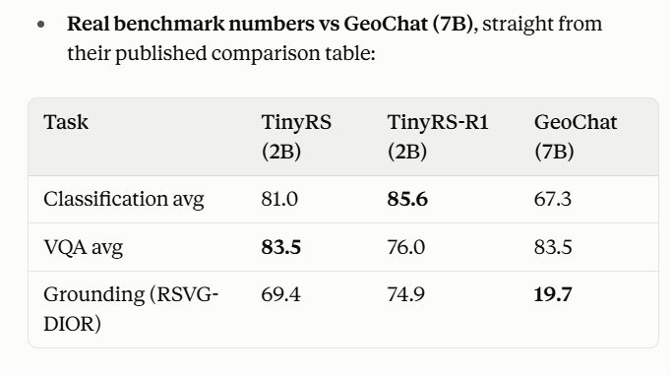

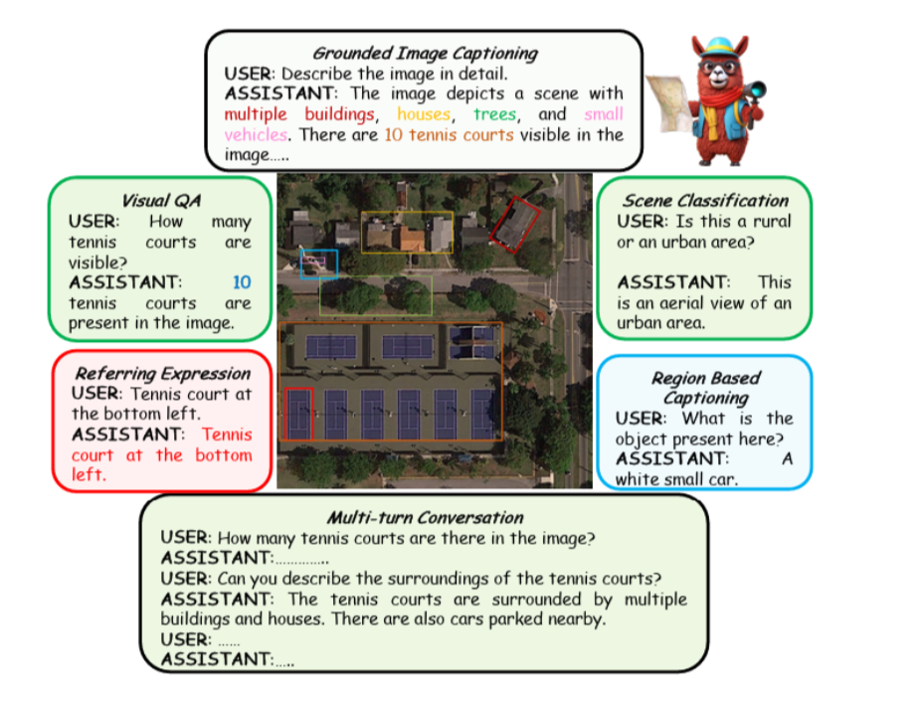
This model can also generate bounding boxes to for explainability so we can use this for vqa

2nd : model to process SAR images form sentinel 1
(shared vision encoder for optical, SAR, and their fusion )

TerraFM (arXiv:2506.06281 (2025); code/weights: mbzuai-oryx/TerraFM (GitHub), MBZUAI/TerraFM (Hugging Face)

TerraFM for encoding both images
fusion-at-encoder-level using a dual-branch backbone (SAR branch + optical branch) with gated cross-attention fusion before the LLM, inspired by "Gated-Guided Fusion for Optical-SAR Object Detection" (2026)

3rd : model for bitemporal analysis
ChangeChat - 4-bit Quantization (Down to ~6GB–8GB VRAM)
(e.g., RTX 3060, RTX 4060) - quantization needed to be done (manually)
Delta VL
encode image-t1 and image-t2 separately with TerraFM, compute an explicit difference embedding between them (not just concatenation), then feed [emb-t1, emb-t2, delta] through a projector into your LLM, fine-tuned on CDVQA

IN THIS WE NEED TO DESIGN LIKE GETTING THE OUTPUT OF IMAGE FROM TERRAFM WE NEED TO CONCATE OR MAKE LINEAR HEAD BY PASSING FROM DARFT AND TCSSM FRAMEWORK AND THEN GETTING INTO SOME PROJECTED LLM BY USING CHANGE AS PARAMETER

DARFT USING SIMPLE NEURAL NETS FOR FIXING THE PIXEL LEVEL THINGS
TCSSM USES MAMBA BASED S6 BLOCKS , IFXES THE CONTEXT (USING THE TEXT QUESTION (CDVQA))

DeltaVLM (2025, instruction-guided difference perception) and TCSSM (arXiv:2508.08974, 2025)

Will try to read this paper nd understand things ( which has concatenation and change , so we will produce or design that part rather than reproducing the papers …what say ?)

4th : segmentation model ( for on demand segmentation of different areas on optical geo special data )
(given a point, box, or rough region you click/select, it produces a precise pixel-level mask of that object )
https://huggingface.co/YiminJimmy/MM-OVSeg
https://arxiv.org/pdf/2603.17528 (MM-OVSeg: Multimodal Optical–SAR Fusion for Open-Vocabulary Segmentation in Remote Sensing)
SAM(segment anything model)
Kirillov et al., ICCV 2023, arXiv:2304.02643; weights: Meta AI segment-anything repo

5th : Vision Encoder (cross-attention fusion )
TerraFM (https://huggingface.co/MBZUAI/TerraFM)

AFTER EVRYTHING GETS COMPLETED WE CAN TAKE STEPS LIKE:
We can take steps for hardening against the failures that is also reserached …
DARFT (arXiv:2512.24591, Dec 2025) identifies that most CDVQA failures aren't clean wrong-answers but "decision-ambiguous samples" — near-tie confidence between the right answer and a close distractor — and fixes this with a two-stage SFT-then-GRPO (reinforcement) reward pipeline.

So in short we can have Con fidence score for SAR failures using DARFT
Also we need to do something for domain change check up or generalising steps …
AI told …
TCSSM (arXiv:2508.08974) tackles the harder, more realistic version of this problem: domain-generalized CDVQA using a state-space model conditioned on text, tested with a new disaster-focused dataset (BrightVQA) that fuses imagery with textual geo-disaster reports. Relevant to you because ISRO's evaluation set will be Cartosat/RISAT imagery your model has never seen in training (BigEarthNet.txt is European Sentinel data) — this is literally the domain-shift problem TCSSM addresses.

This was the things what i have also gone through and i wat you to just read about this too for fusion ..
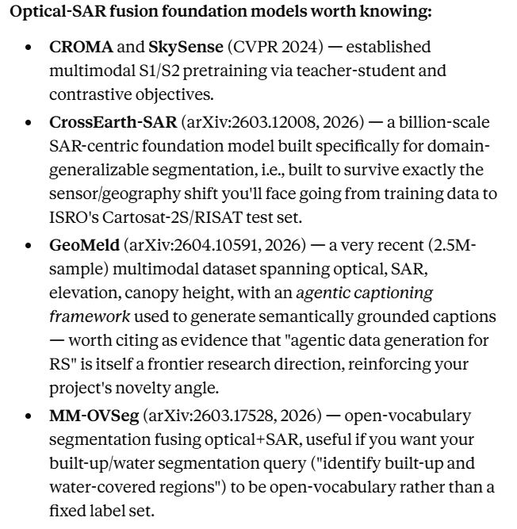

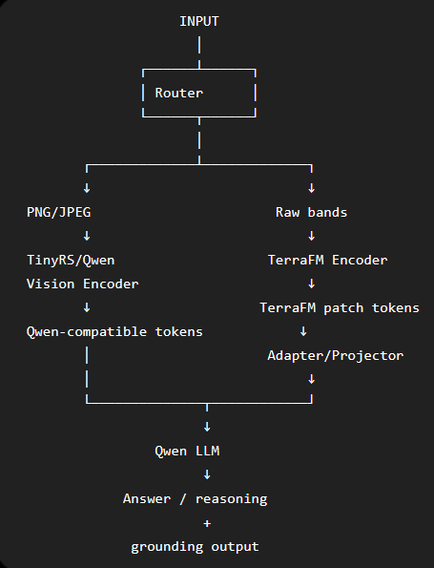

To make the output tokens from terraFM encoder to be compatible with the qwen llm input, we will use Adapter (Perceiver Resampler + 2D Coordinate Conditioning),(information compressor + geographic map )
We can freeze the terraFM encoder and qwen llm and only train the adapter on https://huggingface.co/datasets/BIFOLD-BigEarthNetv2-0/BigEarthNet.txt dataset
Initially, freeze (TerraFM+qwenLLM), train also the adapter using (VQA loss+grounding loss)
I next stage,can finetune qwenLLM using LoRA
Research and References
Datasets
- BigEarthNet.txt (arXiv:2603.29630) — primary source: SAR + optical + captions/VQA/grounding for training.

- VRSBench (arXiv:2406.12384) — single-image VQA/captioning/grounding evaluation.
- RSVQA (rsvqa.sylvainlobry.com) — additional VQA evaluation.
- CDVQA (built on the SECOND dataset) — bi-temporal change-VQA fine-tuning and evaluation.
- sentinel2cap( for image + sar fine tuning)
Models used
- TinyRS-R1 (arXiv:2505.12099) — primary single-image VQA/caption/grounding model.
- TerraFM (arXiv:2506.06281) — optical–SAR fusion vision encoder.
- SAM (arXiv:2304.02643) — on-demand region segmentation.
- Gemma 3n E2B (Google, 2025) — lightweight orchestrator/reasoning LLM.
Architecture references
- DeltaVLM (Remote Sensing journal, 2025) — difference-perception design for change-VQA.
- TCSSM (arXiv:2508.08974) — text-conditioned state-space fusion for domain-generalized change-VQA.
- ZoomEarth (arXiv:2511.12267) — active-perception tiling for large GeoTIFFs.
- GeoChat (arXiv:2311.15826) — baseline reference for grounded-token design.

